Практикум 2
Тема: «Разработка игрового приложения со словами»

Цель: разработать игровое приложение со словами на платформе Windows Forms с использованием языка программирования C#, освоить создание графического интерфейса, реализовать основные игровые механики и обеспечить интерактивность программы.

Ход работы
- Создадим интерфейс нашей программы:
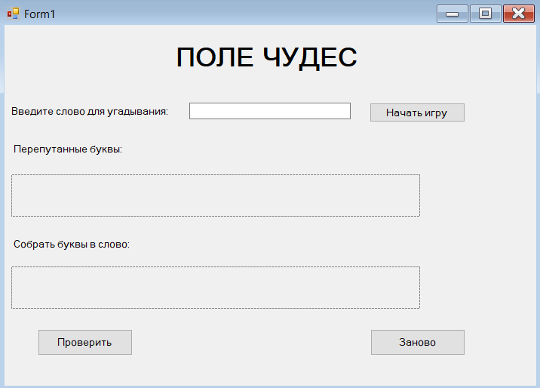
- Напишем код для нашей программы:
using System;
using System.Collections.Generic;
using System.Drawing;
using System.Linq;
using System.Windows.Forms;

namespace FieldOfWondersGame
{
public partial class Form1 : Form
{
private string originalWord = "";
private List<char> shuffledLetters = new List<char>();
private List<Button> mixedLetterButtons = new List<Button>();
private List<Button> resultLetterSlots = new List<Button>();
private int attempts = 0;
private bool gameStarted = false;

public Form1()
{
InitializeComponent();
InitializeGame();
}

private void InitializeGame()
{
this.Text = "Поле чудес";
this.Size = new Size(500, 500);
this.StartPosition = FormStartPosition.CenterScreen;
this.BackColor = Color.White;

buttonStart.Click += ButtonStart_Click;
buttonCheck.Click += ButtonCheck_Click;
buttonNewGame.Click += ButtonNewGame_Click;
}

private void ButtonStart_Click(object sender, EventArgs e)
{
string inputWord = textBoxInputWord.Text.Trim().ToUpper();

if (string.IsNullOrWhiteSpace(inputWord))
{
MessageBox.Show("Введите слово для начала игры!");
return;
}

if (inputWord.Length < 3)
{
MessageBox.Show("Слово должно содержать минимум 3 буквы!");
return;
}

if (!inputWord.All(char.IsLetter))
{
MessageBox.Show("Слово должно содержать только буквы!");
return;
}

StartNewGame(inputWord);
}

private void StartNewGame(string word)
{
originalWord = word;
shuffledLetters = ShuffleLetters(word.ToList());
attempts = 0;
gameStarted = true;

SetupMixedLettersPanel();
SetupResultPanel();

ShowGameElements();

labelResult.Text = "";
labelResult.Visible = false;
}

private List<char> ShuffleLetters(List<char> letters)
{
Random random = new Random();
List<char> shuffled = new List<char>(letters);

for (int i = shuffled.Count - 1; i > 0; i--)
{
int j = random.Next(i + 1);
char temp = shuffled[i];
shuffled[i] = shuffled[j];
shuffled[j] = temp;
}

return shuffled;
}

private void SetupMixedLettersPanel()
{
flowLayoutPanelMixed.Controls.Clear();
mixedLetterButtons.Clear();

foreach (char letter in shuffledLetters)
{
Button letterButton = new Button
{
Text = letter.ToString(),
Size = new Size(40, 40),
Font = new Font("Arial", 14, FontStyle.Bold),
BackColor = Color.LightBlue,
ForeColor = Color.Black,
Tag = letter,
Margin = new Padding(5),
Cursor = Cursors.Hand
};

letterButton.Click += MixedLetterButton_Click;
mixedLetterButtons.Add(letterButton);
flowLayoutPanelMixed.Controls.Add(letterButton);
}
}

private void SetupResultPanel()
{
flowLayoutPanelResult.Controls.Clear();
resultLetterSlots.Clear();

for (int i = 0; i < originalWord.Length; i++)
{
Button slotButton = new Button
{
Text = "",
Size = new Size(40, 40),
Font = new Font("Arial", 14, FontStyle.Bold),
BackColor = Color.White,
ForeColor = Color.Black,
Tag = -1,
Margin = new Padding(5),
Cursor = Cursors.Hand
};

slotButton.Click += ResultSlotButton_Click;
resultLetterSlots.Add(slotButton);
flowLayoutPanelResult.Controls.Add(slotButton);
}
}

private void MixedLetterButton_Click(object sender, EventArgs e)
{
if (!gameStarted) return;

Button clickedButton = sender as Button;
if (clickedButton == null) return;

char letter = (char)clickedButton.Tag;
int buttonIndex = mixedLetterButtons.IndexOf(clickedButton);

for (int i = 0; i < resultLetterSlots.Count; i++)
{
if (string.IsNullOrEmpty(resultLetterSlots[i].Text))
{
resultLetterSlots[i].Text = letter.ToString();
resultLetterSlots[i].Tag = buttonIndex;
resultLetterSlots[i].BackColor = Color.LightGreen;
break;
}
}

UpdateGameState();
}

private void ResultSlotButton_Click(object sender, EventArgs e)
{
if (!gameStarted) return;

Button clickedSlot = sender as Button;
if (clickedSlot == null || string.IsNullOrEmpty(clickedSlot.Text)) return;

int buttonIndex = (int)clickedSlot.Tag;
if (buttonIndex >= 0 && buttonIndex < mixedLetterButtons.Count)
{
mixedLetterButtons[buttonIndex].Enabled = true;
mixedLetterButtons[buttonIndex].BackColor = Color.LightBlue;
}

clickedSlot.Text = "";
clickedSlot.Tag = -1;
clickedSlot.BackColor = Color.White;

UpdateGameState();
}

private void ButtonCheck_Click(object sender, EventArgs e)
{
if (!gameStarted) return;

attempts++;

string userWord = "";
foreach (Button slot in resultLetterSlots)
{
userWord += slot.Text;
}

if (userWord == originalWord)
{
labelResult.Text = "Правильно!";
labelResult.ForeColor = Color.Green;
labelResult.Font = new Font("Arial", 12, FontStyle.Bold);

foreach (Button slot in resultLetterSlots)
{
slot.BackColor = Color.Green;
slot.ForeColor = Color.White;
}

foreach (Button mixedButton in mixedLetterButtons)
{
mixedButton.Enabled = false;
mixedButton.BackColor = Color.LightGray;
}

buttonCheck.Enabled = false;
}
else
{
labelResult.Text = $"Неверно! Правильное слово: {originalWord}";
labelResult.ForeColor = Color.Red;
labelResult.Font = new Font("Arial", 12, FontStyle.Bold);

for (int i = 0; i < resultLetterSlots.Count; i++)
{
if (i < userWord.Length && i < originalWord.Length)
{
if (userWord[i] == originalWord[i])
{
resultLetterSlots[i].BackColor = Color.Green;
}
else
{
resultLetterSlots[i].BackColor = Color.Red;
}
}
}
}

labelResult.Visible = true;
}
private void ButtonNewGame_Click(object sender, EventArgs e)
{
ResetGame();
textBoxInputWord.Text = "";
textBoxInputWord.Focus();
}

private void ResetGame()
{
originalWord = "";
shuffledLetters.Clear();
mixedLetterButtons.Clear();
resultLetterSlots.Clear();
attempts = 0;
gameStarted = false;

flowLayoutPanelMixed.Controls.Clear();
flowLayoutPanelResult.Controls.Clear();

HideGameElements();

labelResult.Text = "";
labelResult.Visible = false;
}

private void ShowGameElements()
{
labelMixedTitle.Visible = true;
flowLayoutPanelMixed.Visible = true;
labelResultTitle.Visible = true;
flowLayoutPanelResult.Visible = true;
buttonCheck.Visible = true;
buttonNewGame.Visible = true;

buttonStart.Enabled = false;
textBoxInputWord.Enabled = false;
}

private void HideGameElements()
{
labelMixedTitle.Visible = false;
flowLayoutPanelMixed.Visible = false;
labelResultTitle.Visible = false;
flowLayoutPanelResult.Visible = false;
buttonCheck.Visible = false;
buttonNewGame.Visible = false;

buttonStart.Enabled = true;
textBoxInputWord.Enabled = true;
}

private void UpdateGameState()
{
bool allSlotsFilled = resultLetterSlots.All(slot => !string.IsNullOrEmpty(slot.Text));
buttonCheck.Enabled = allSlotsFilled;
}

private void Form1_Load(object sender, EventArgs e)
{

}
}
}
- Протестируем наше приложение
